1. Go to this folder: **R:\storage\libarchive\b\1. Processing\8. Other Projects\Scholars-Mine-GitHub\Stand Alone Author Split**
2. Open the “**run”** python file with **Visual Studio Code**
   1. Visual Studio Code is on **Apps Anywhere** or can be downloaded here: <https://code.visualstudio.com/download>

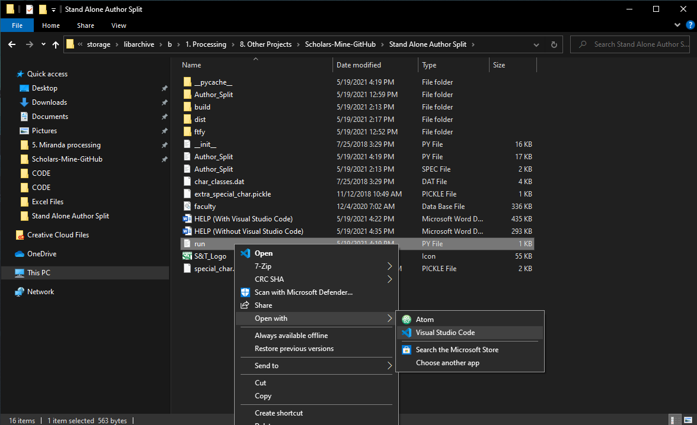

1. This is what the file should look like…

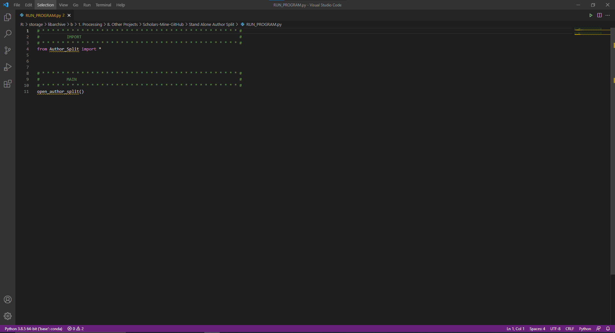

1. In the upper right-hand corner of Visual Studio Code, click on the green arrow to run the program.

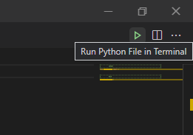

1. The program should launch and look like the following…

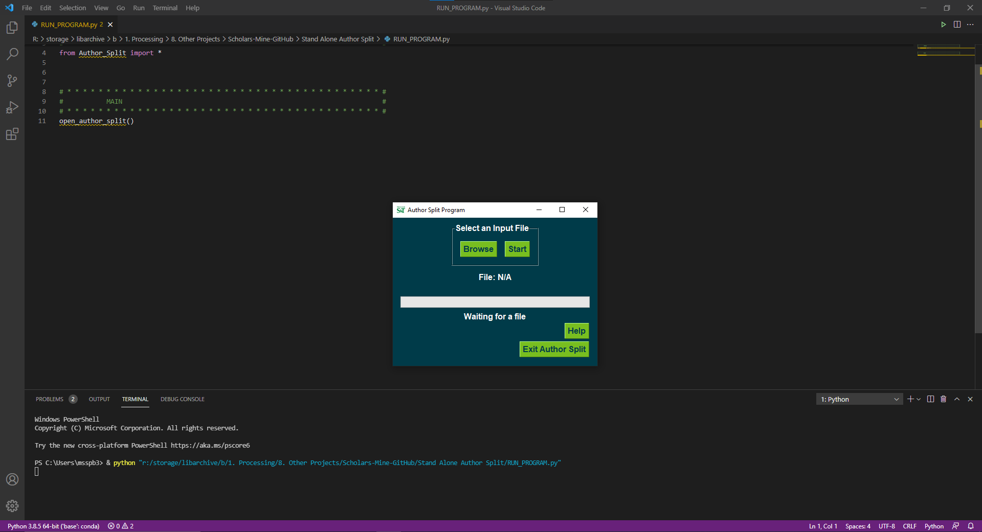

1. Click on browse to find a file.
2. Select a file that has **“_ReadyForAuthorSplit”** at the end and click open (bottom right hand corner).
   1. If your file does not have this, run it through the **“Harvest & Reformat”** program in the **“Control Panel Program”** that can be found here: **R:\storage\libarchive\b\1. Processing\8. Other Projects\Excel Files**

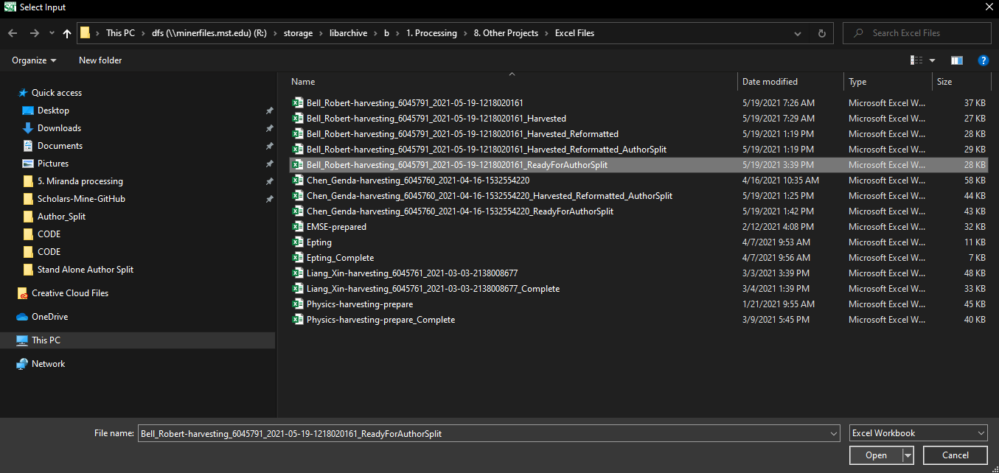

1. Press Start

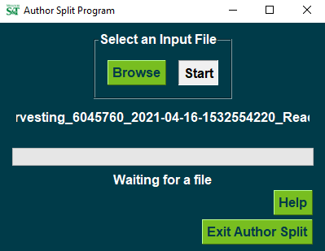

1. If it says **“Excel Created”** below the progress bar, then the program is finished.

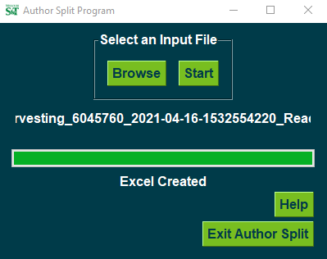

1. You can now click “Exit Author Split” or close the window with the “X” in the upper right-hand corner of the window OR select browse again to run another file.

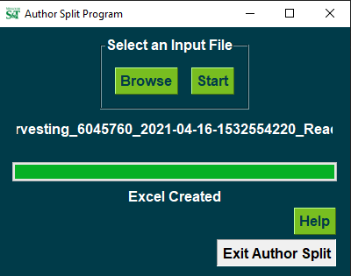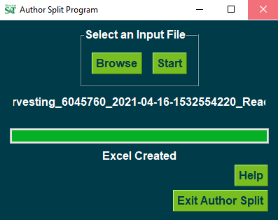

1. You can close out of Visual Studio Code with the “X” in the upper right-hand corner of the window.

